

Competitiveness and Growth Prospects for Irish Tourism

Prepared for ITIC by CHL Consulting Group

October, 2009

Report prepared on behalf of ITIC by:
CHL Consulting Group
40 Northumberland Avenue
Dun Laoghaire
Co Dublin
Tel: +353 1 2844760
Fax: +353 1 2844775
Email: mail@chl.ie
Web: www.chl.ie


Copyright and Related Rights Act, 2000; Freedom of Information Acts 1997 and 2003

© Copyright 2009, CHL Consulting Company Ltd. & Irish Tourist Industry Confederation.

This document is copyright under the Copyright and Related Rights Act, 2000.

The information and documentation contained herein is of a confidential nature and is supplied to the Irish Tourist Industry Confederation for their exclusive use only.

Vers4/smcm/06.10.09

CONTENTS
Page No.

Executive Summary i

- INTRODUCTION 1

- TOURISM TRENDS AND PROSPECTS 2

2.1 Performance to Date 2
2.2 Trend in 2009 11
2.3 Outlook 2010-2015 15

- COMPETITIVE POSITION 20

3.1 Introduction 20
3.2 Ireland’s Competitive Performance 21
3.3 Competitive Issues and Priorities 25

- EMPLOYMENT IN TOURISM 40

4.1 Total Employment 40
4.2 Status of Employment in Tourism 41
4.3 Future Trends 42

LIST OF FIGURES

Page No.

Figure 1: Growth in Total Overseas Visitors and Associated Real Revenue,
1985-2008 2
Figure 2: Trends in Arrivals from Major Source Markets, 2000-2008 5
Figure 3: Growth Trends in Holiday Arrivals by Principal Market, 2000-2008 6
Figure 4: Overseas and Domestic Tourist Growth Rates, 2000-2008 7
Figure 5: Real Increase in the Value of the Domestic Market, 2000-2008 8
Figure 6: Market Distribution of Hotel Bednight Demand 10
Figure 7: Market Source of Growth in Hotel Bednight Demand, 2001-2007 10
Figure 8: International Tourist Arrivals, World 12
Figure 9: Overseas Visitors & Revenue Projections ± 5%, 2008-2015 18
Figure 10: Domestic Trips Projections, ± 5%, 2008-2015 18
Figure 11: Domestic Revenue Projections, ± 5%, 2008-2015 19

Figure 12: Tourism Competitiveness Pyramid 20
Figure 13: Ireland’s Share of World and European Tourist Arrivals, 1985-2008 21
Figure 14: Ireland’s Share of Northern European Tourist Arrivals, 1985-2008 22
Figure 15: Price Competitiveness Indicator for Ireland 2000-2009 26
Figure 16: Harmonised Index of Consumer Prices 27
Figure 17: Trend in Hotel Room & Bed Occupancy Rates 36

LIST OF TABLES
Page No.

Table 1: Projected Results for Irish Tourism, 2009 iii
Table 2: Tourist Demand Outlook, 2010-2015 iii
Table 3: Adjusted Estimate for Tourism Related Employment, 2008 vi
Table 4: Projected Trend in Tourism Dependent Employment vii

Table 2.1: Trends in Overseas Tourism to Ireland, 2000-2008 4
Table 2.2: Arrivals from Major Markets 2000-2008 4
Table 2.3: Trends in Domestic Holiday Tourism, 2000-2008 9
Table 2.4: Tourist Bednights, 2001 and 2008 9
Table 2.5: Tourism to Ireland, Jan-July 2009 13
Table 2.6: Domestic Tourism, Jan-Mar 2009 13
Table 2.7: Forecasts for Key Economic Indicators, 2009 14
Table 2.8: Projected Results for Irish Tourism, 2009 15
Table 2.9: Tourist Demand Outlook, 2010-2015 17

Table 3.1: Ireland’s Share (%) of Outbound Tourist Numbers from the Main Source Markets, 2002-2008 23
Table 3.2: Ireland’s Competitive Advantages 23
Table 3.3: Key Competitive Factors 24
Table 3.4: Aspects Considered Less than Good Value 24
Table 3.5: Price Indices for Selected Tourism-Related Products 2006-2009 27
Table 3.6: Labour Costs in Industrialised Countries, 2000-2008 30
Table 3.7: Irish VAT Rates relative to the rest of the EU (EU 27) 31
Table 3.8: Weekly Air Access Capacity to the island of Ireland, 2005-2008 33
Table 3.9: Weekly Sea Access Capacity, 2006-2009 34

Table 4.1: Employment in Tourism, 2007-2008 40
Table 4.2: Adjusted Estimate for Tourism Related Employment, 2008 41
Table 4.3: Status of Tourism Related Employment 42
Table 4.4: Projected Trend in Tourism Dependent Employment 43

Competitiveness and Growth Prospects

- Executive Summary -

1. OVERSEAS TOURISM
The Irish Tourism Industry has achieved remarkable growth over the last two decades, with overseas tourist arrivals rising from 1.95 million in 1985 to 7.74 million in 2007, before falling back to 7.44 million in 2008. The increase between 1985 and 2007 represents a compound annual growth rate of almost 6.5% per annum over 22 years - a record unmatched by any other European destination.

In terms of overall trends, the following points may be noted:

- The average length of stay has been relatively constant over the period 2000-2008 at 7.5 nights for all overseas visitors and 6.94 nights for holidaymakers.

- Expenditure per head has fallen by 28% in real terms since 1985 with the rate of decline accelerating during the past 5 years.

- Reduced air and sea fares have accounted for a large part of the drop in yield. If carrier revenues are excluded, the real decline in expenditure per tourist between 2000 and 2008 was 12.5%.

- The proportion of tourists on holidays averaged 52% between 2000 and 2008, but fell to 48% in 2008 reflecting the impact of the recession on travel during the second half of the year.

- Mainland European markets have been the primary driver of growth during the past decade, accounting for 90% of the increase in overseas visitor arrivals since 2000.

2. THE DOMESTIC MARKET
The domestic market has become an increasingly important source of business for the Irish tourism industry. Between 2000 and 2008, the number of domestic trips of one or more nights away from home rose by 52% from 5.48 million to 8.33 million. This represents a cumulative annual growth rate (CAGR) of 5.4%, which was more than twice the CAGR of 2.3% in overseas tourist arrivals during the same period.

The domestic holiday market performed particularly strongly between 2000 and 2008, increasing by 74% from 2.52 million to 4.39 million trips. This contrasted with the flow of overseas holiday tourist arrivals which increased by just over 8% during the same period.

Trends in the domestic market include the following:

- The average length of trip has fallen by almost 17% since 2000; the drop in the average length of holiday trips has been greater, at nearly 22%, from 4.56 nights in 2000 to 3.57 nights in 2008.

- The average spend per trip has increased in real terms since 2000; the increase up to 2006 was 18%, but this has fallen back, and the average in 2008 was just 6% above the 2000 figure.

- The shorter average trip duration combined with increased expenditure has produced a significant increase in yield.

The impact of the rapid growth in the domestic market can be seen in the fact that 90% of the increase in hotel bednight demand between 2001 and 2007 was generated by the home market, and only 9% by overseas tourists. The industry has therefore become increasingly dependent on domestic demand and the evidence suggests that overseas visitors will, at best, only partially compensate for a decline in the domestic market, even when overseas markets are performing well.

3. OUTLOOK
2009 is proving to be a very difficult year for Irish tourism. The number of visitors to Ireland for the first seven months of the year was down by 10.4% on the same period in 2008. All markets have been affected, with a particularly steep drop being recorded by the British market. The domestic market has also contracted sharply, with total nights and holiday nights being down by 9% and 27% respectively in the first quarter. The shift of the Easter holidays to April (the second quarter) undoubtedly had an impact, but the figures indicate a considerable cut-back in spending on holidays.

While it is very difficult to forecast the outturn for 2009, current trends and industry experience suggest the following range of possible results (Table 1):
Table 1: Projected Results for Irish Tourism, 2009

 | Overseas |  | Domestic
 | Visitors | Revenue | Trips | Revenue
Best Case | -8% | -12% | -8% | -13%
Central Projection | -10% | -18% | -11% | -16%
Worst Case | -12% | -21% | -14% | -20%

Source: CHL Estimates.

There are some encouraging signs that the recession may be bottoming out in our major source markets. However, the return to growth will be slow, with high rates of unemployment persisting and consumer spending remaining depressed. Expenditure on tourism and travel will therefore be slow to recover, and real growth may not be seen until 2011 / 2012. Further issues of concern for Ireland will be continuing weakness in competitiveness and reduced access capacity.

Based on the present outlook and assumptions regarding access capacity, visitor expenditure, and national and international economic performance, the following outlook is projected for the period 2010-2015 (Table 2):

Table 2: Tourist Demand Outlook, 2010-2015

Year | 2008 | 2009 | 2010 | 2011 | 2012 | 2013 | 2014 | 2015
Overseas Visitors (000s) | 7,436 | 6,682 | 6,666 | 6,783 | 6,961 | 7,198 | 7,443 | 7,697
Overseas Revenue (€m) | 4,571 | 3,738 | 3,804 | 3,987 | 4,255 | 4,400 | 4,550 | 4,705
Domestic Trips (000s) | 8,339 | 7,505 | 7,130 | 7,201 | 7,417 | 7,788 | 8,255 | 8,751
Domestic Revenue (€m) | 1,546 | 1,294 | 1,180 | 1,260 | 1,335 | 1,441 | 1,569 | 1,706
Total Revenue (€m) | 6,117 | 5,032 | 4,984 | 5,247 | 5,590 | 5,841 | 6,118 | 6,412

Source: CHL Estimates. Notes: Revenues in 2008 prices; Northern Ireland visitors and revenues not included.

4. COMPETITIVE POSITION
Ireland has suffered a significant loss in competitiveness as a tourist destination in recent years. This is reflected in falling market share in key source markets and negative trends in visitors’ perceptions of value for money and the country’s competitive advantages. Unless corrected, this loss of competitiveness will both intensify the severity of impact of the economic recession and act as a brake on recovery. The key issues and priorities may be summarised as follows:

  - Costs and Prices
While Ireland’s rate of price inflation, as measured by the Harmonised Index of Consumer Prices, has become more closely aligned with the Eurozone average since 2004, the absolute level of prices remains high in comparison with those obtaining in competitor destinations. In particular, although there has been a steep fall in prices for hotel accommodation, many other goods and services purchased by tourists continue to rise in price. It cannot be presumed that deflation in Ireland will automatically guarantee an immediate and sustained improvement in price competitiveness since most of our major source markets are also experiencing deflation. Measures must be taken to address the cost base in Ireland in order to restore lost competitiveness. The priority areas are:

- labour costs: need to be reduced in both the public and private sectors
- indirect taxation: increases including the rise in VAT and the introduction of the airport departure tax have pushed up prices for tourists and should be reversed
- public sector charges: have increased by a multiple of the rate of inflation in recent years and should be reduced or at least frozen for a sustained period.

  - Access
Given Ireland’s island location, international surface and air connectivity is the lifeblood of the economy, and of tourism in particular. A real danger exists that falling yields coupled with further airline consolidation will lead to the loss of air services to the island. The challenge for Ireland is to strive to maintain the present air and sea access levels, which have already suffered cuts in 2009.

  - Product

- Primary Product
The primary product - Irish people, the natural environment and cultural heritage - has been affected by the intensive development of the Celtic Tiger years. A failure to address threats to our primary product will result in its steady deterioration with serious consequences for tourism. In particular, our environment - both rural and urban - which is at the heart of the Irish tourism product, requires careful stewardship and nurturing. All parties have a role in its protection and presentation to visitors with sustainability being a governing principle in planning, development and operations.

- Accommodation
Encouraged by tax-based incentives, the number of hotels has doubled in the past 13 years, and the bedroom stock has grown from 39,763 in 2001 to 60,148 in 2009, an increase of 51%. With the downturn in demand, this excessive growth in capacity has resulted in a severe fall in occupancy rates and profitability, and many properties have already gone into receivership. The only effective remedy is to cut capacity, but if this reduction is not managed, it will happen in a chaotic fashion which could cause lasting damage. Possible measures include: full or partial closure of hotels, especially those in unviable locations, conversion of properties to other uses, and changes in the regulations governing hotel capital allowances to allow investors to exit early and their hotels to close.

- Activities and Attractions
In seeking to strengthen our tourism product, the emphasis in the coming years must be on the key attractors. Attendances at both admission-charging and free attractions indicate a strong enthusiasm among visitors for cultural, historical and heritage, and craft-based tourism products. There is clear scope for strengthening product development, innovation and integration in these areas.

Sustained public sector investment in facilities associated with the tourism product is necessary and fully justified in terms of the economic benefit which would accrue, and the recovery potential which exists for Irish tourism, including restoration of the Tourism Product Development Scheme. Government must continue to direct investment towards the tourism product so that maximum advantage can be taken from the recovery in international travel which will commence in 2010 and accelerate in 2011 and 2012.

  - Marketing
Marketing is a vital driver of tourism growth, since it seeks to shift available international tourism demand towards Ireland. At a time of economic downturn and increased competition, a cut-back in marketing would be highly damaging to Ireland’s position.

It is imperative that in the present down-cycle the commitment to overseas and domestic marketing is maintained and, if possible, increased. Any diminution of the commitment will assuredly lead to loss of market share and any such loss will be extremely difficult and expensive to recover.
  - Human Resources
People are an integral part of the tourism product. Within the industry, service quality is a function of management competence and employee expertise. Both are shaped by skills development and training. It is essential that the industry strengthens its commitment to human resource development and that the Government remains committed to the €149m allocation to Fáilte Ireland for investment in training and human resources over the period 2007-2013.

The recession is likely to see the re-entry of many more Irish people into the industry. This is to be welcomed. Particular attention should be paid to the promotion of career paths within the industry and the retention of people working in tourism through continuous professional skills development.

5. EMPLOYMENT IN TOURISM
Current tourism employment estimates prepared by Fáilte Ireland show that there were an estimated 258,000 people working in Irish tourism in 2008. This estimate includes employment in sectors that are only partly dependent on tourism – notably restaurants and public houses – because establishments in these sectors usually generate much of their business in their local area.

The Fáilte Ireland figures can be adjusted by the findings of a survey conducted by CHL in 2003 when establishments surveyed were asked to estimate the share of their turnover attributable to tourism. Applying the findings of this survey, and assuming that employment is directly related to turnover, produces an estimate for tourism-dependent employment of almost 171,000 in 2008. The distribution of this employment is shown in Table 3.

Table 3: Adjusted Estimate for Tourism Dependent Employment, 2008

Sector
Hotels | 64,854
Guesthouses | 3,956
Self-catering | 4,468
Licensed Restaurants | 17,285
Non-licensed restaurants | 3,924
Public Houses | 18,177
Tourism Services and Attractions | 58,127
Total | 170,791
Looking to the future, if it can be anticipated that employment in tourism will follow the performance of the industry in terms of activity and revenue, the numbers employed in the industry (based on the adjusted total) may be projected as set out in Table 4.

Table 4: Projected Trend in Tourism Dependent Employment

Year | Total
2008 | 170,791
2009 | 142,590
2010 | 141,000
2011 | 146,000
2012 | 154,000

There is a risk that the actual outturn could be worse than indicated in 2010 should the performance of the domestic economy and domestic demand deteriorate further than currently projected, and if the hotel sector, in particular, experiences widespread business failure and closures.
1. INTRODUCTION

Following a lengthy period of sustained growth, the Irish tourism industry has experienced a severe downturn precipitated by the global economic crisis. The recession has severely curtailed outbound travel demand from Ireland’s major source markets, and the domestic market has also contracted sharply.

Despite the tough economic and market conditions, the Irish tourism industry will continue to be an important generator of employment and economic activity throughout the country. The priorities now are to ensure that the industry weathers the recession and is in as strong a position as possible to compete effectively for business when the global economy improves and the key markets begin to recover. Restoring our competitiveness as a destination is a vital task, and all stakeholders - the industry, government, state agencies and local authorities - have an important role to play in this.

Against this background, ITIC commissioned CHL Consulting to analyse the prospects for Irish tourism over the period up to 2015. The scope of the paper comprises:

- a review of trends in international tourism and current projections for Ireland’s main source markets, with particular reference to economic performance and consumer behaviour.
- a review of the key factors that influence Ireland’s competitiveness as a tourism destination;
- a review of the figures for employment in tourism estimated by Fáilte Ireland, and assessment of the net employment at sectoral level attributable to tourism in terms of full-time job equivalents.

The research was conducted during July and August, 2009. The findings and conclusions are presented in this paper.

2. TOURISM TRENDS AND PROSPECTS

2.1 Performance to Date
2.1.1 Overseas Markets
The Irish Tourism Industry has achieved remarkable growth over the last two decades, with overseas tourist arrivals rising from 1.95 million in 1985 to 7.74 million in 2007, before falling back to 7.44 million in 2008.

The increase between 1985 and 2007 represents a compound annual growth rate of almost 6.5% per annum over 22 years - a record unmatched by any other European destination. During the same period, Ireland recorded a considerable real increase of 293% in annual revenue earned from overseas tourists, representing a compound annual growth rate of 5%. Figure 1 highlights the successful growth path of the industry since 1985.

Figure 1: Growth in Total Overseas Visitors and Associated Real Revenue,
1985-2008

Note: revenue in constant 1985 prices. Source: Fáilte Ireland
As the global recession took hold in 2008, particularly in the latter half of the year, the international travel and tourism industry contracted. Although, on a year-on-year basis, growth in Irish tourism remained positive during the first six months, there was a sharp fall in overseas visitor arrivals in the third and fourth quarters of -6.5% and -5.2% respectively. As might be expected, the holiday market experienced the steepest decline with holiday visitors from overseas down by 8%. The North American and British source markets were the most badly affected while overall demand from Mainland Europe was reasonably stable.

Despite this fall in numbers, tourism continued to deliver a substantial contribution to the Irish economy. In total, the revenue earned from international tourism in 2008 amounted to €4.8 billion, inclusive of Irish carrier receipts of €686 million. This total was just below the record earnings of €4.9 billion achieved in 2007.

In terms of overall trends, the following points may be noted:

- Average length of stay has been relatively constant over the period 2000-2008: the average for all overseas tourists during this period was 7.5 nights, while that for overseas tourists on holidays was 6.94 nights. The fluctuations around these averages have been very small.

- Expenditure per head has fallen in real terms with the rate of decline accelerating during the past 5 years: the average revenue per overseas tourist has fallen by 28% in real terms since 1985 (as adjusted by the Consumer Price Index). Between 1985 and 2000, average revenue per head fluctuated around a consistent mid-point but, since then, there has been a steep decline and, in real terms, the results since 2004 have been below the lowest point recorded between 1985 and 2000. As the average number of nights per tourist has remained fairly constant, this drop in revenue reflects a substantial real decline of almost 20% in average daily expenditure since 2000 - see Table 2.1.

- Reduced air and sea fares have accounted for a large part of the drop in yield: the share of total overseas tourist revenue accounted for by carriers has fallen from 23% in 2000 to 15% in 2008. If carrier revenues are excluded, the real decline in expenditure per tourist between 2000 and 2008 was 12.5%.
- The proportion of tourists on holidays averaged 52% between 2000 and 2008: however, the proportion in 2008 fell to 48% reflecting the impact of the recession during the second half of the year.

Table 2.1: Trends in Overseas Tourism to Ireland, 2000-2008

Year | Number of  visitors  (000s) | Revenue excl. carriers  €m | Revenue  excl. carriers  2000 prices  €m | Revenue  per head  excl. carriers  2000 prices  € | Total Nights  m | Nights  per  Trip | Revenue  per night  excl. carriers  2000 prices  €
2000 | 6,181 | 3,543 | 2,730 | 442 | 46,169 | 7.47 | 59
2001 | 5,840 | 3,817 | 2,857 | 489 | 44,552 | 7.63 | 64
2002 | 5,919 | 3,828 | 2,796 | 472 | 44,339 | 7.49 | 63
2003 | 6,178 | 3,882 | 2,861 | 463 | 46,846 | 7.58 | 61
2004 | 6,384 | 3,891 | 2,806 | 439 | 46,604 | 7.30 | 60
2005 | 6,703 | 4,093 | 2,949 | 440 | 49,451 | 7.38 | 60
2006 | 7,417 | 4,502 | 3,102 | 418 | 55,615 | 7.50 | 56
2007 | 7,739 | 4,699 | 3,061 | 396 | 55,628 | 7.19 | 55
2008 | 7,435 | 4,571 | 2,876 | 387 | 59,337 | 7.98 | 48

Source: Derived from Fáilte Ireland Tourism Facts, successive issues

2.1.2 Performance of Key Overseas Markets
The number of arrivals from the principal markets for Ireland since 2000 are shown in Table 2.2. These markets accounted for 80% of the number of overseas tourists who visited Ireland in 2008 - down from 88% in 2000. This reduction in share is attributable both to a lack of growth in demand from Britain and the USA and also to strong growth from other European markets. The share of demand taken by long haul markets outside Europe and North America has remained at a little over 4% over the past eight years.

Table 2.2: Arrivals from Major Markets 2000-2008

Market | 2000  (000’s) | 2005  (000’s) | 2006  (000’s) | 2007  (000’s) | 2008  (000’s) | Share of Total  Demand 2008 %
Great Britain | 3,428 | 3,640 | 3,821 | 3,776 | 3,579 | 48.1
USA | 958 | 854 | 945 | 975 | 849 | 11.4
Germany | 319 | 402 | 417 | 436 | 456 | 6.1
France | 283 | 310 | 360 | 394 | 412 | 5.5
Italy | 186 | 190 | 248 | 265 | 232 | 3.1
Spain | 89 | 171 | 198 | 249 | 243 | 3.3
Netherlands | 179 | 157 | 155 | 155 | 151 | 2.0
Total | 5,442 | 5,724 | 6,144 | 6,250 | 5,922 | 79.6

Source: Fáilte Ireland
The relative growth rates of the major markets are highlighted in Figure 2. As illustrated in the chart, the strong performers have been the Mainland European markets. Indeed, Mainland Europe has been the primary driver of growth since 2000, accounting for 90% of the increase in total overseas arrivals since then. The performance of the British market has been relatively flat, but it continues to be by far the largest source of business, accounting for 48% of arrivals in 2008. More disappointing is the performance of the US market which has remained 10% below the peak recorded in 2000 for most of the period since then, apart from 2006 and 2007.

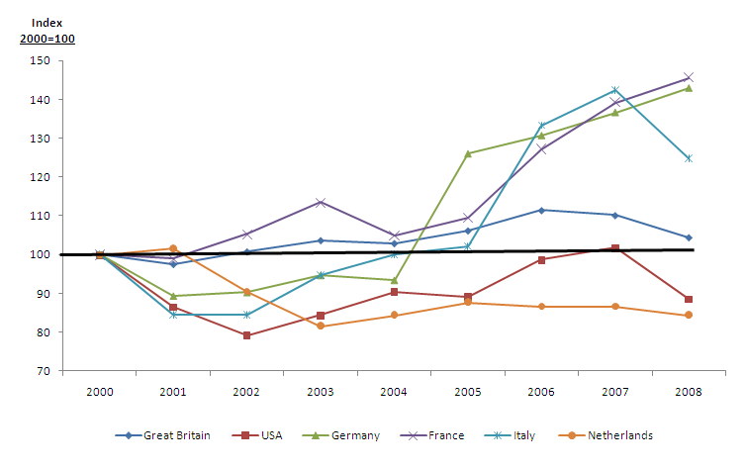
Figure 2: Trends in Arrivals from Major Source Markets, 2000-2008
Source: Fáilte Ireland

Arrivals by tourists whose main purpose of travelling to Ireland is to take a holiday here have not kept pace with overall demand. The share of overseas visitors who are on holidays has slipped from almost 54% in 2000 to 48% in 2008. Granted that there was a particularly steep fall in holidaymakers in 2008, but the general trend in the share of visitors on holidays up to 2008 was downward anyway.

The growth trends in holiday arrivals from the principal market areas are illustrated in Figure 3. The growth in overall holiday arrivals peaked in 2007 when it was 20% above the level recorded in 2000, but it then fell back to a level just 8% above the 2000 level in 2008. [The comparable figures for all overseas tourists were 25% and 20% respectively]. As in the case of total arrivals, Mainland Europe has been the principal driver of growth in holiday arrivals, accounting for 85% of the total increase up to 2007. The British market showed a little growth over the period up to 2007, but fell back sharply in 2008. The North American market has remained stubbornly at least 10% below the record achieved in 2000, while there has been little growth from other long haul markets.

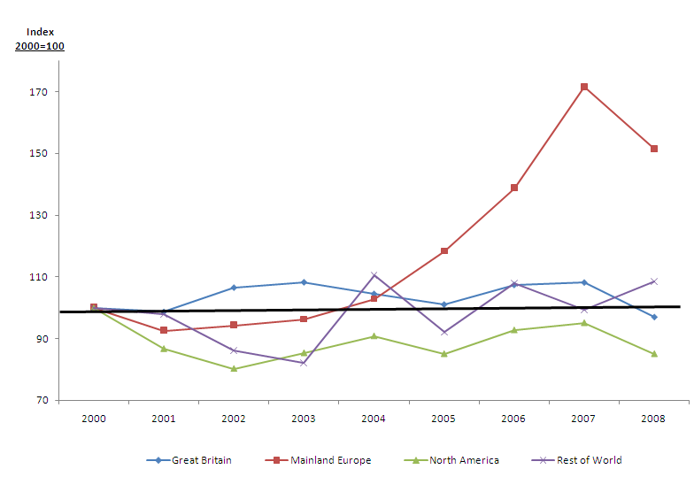
Figure 3: Growth Trends in Holiday Arrivals by Principal Market, 2000-2008
Source: Fáilte Ireland

2.1.3 Domestic Market
The domestic market has become an increasingly important source of business for the Irish tourism industry. Between 2000 and 2008, the number of domestic trips of one or more nights away from home rose by 52% from 5.48 million to 8.33 million. This represents a cumulative annual growth rate (CAGR) of 5.4%, which was more than twice the CAGR of 2.3% in overseas tourist arrivals during the same period.

The domestic holiday market performed particularly strongly between 2000 and 2008, increasing by 74% from 2.52 million to 4.39 million trips. This contrasted with the flow of overseas holiday tourist arrivals which increased by just over 8% during the same period. The respective growth trends are illustrated in Figure 4.

Expenditure on all domestic trips more than doubled from €707m in 2000 to €1,546m in 2008, while expenditure on holiday trips rose from €448m in 2000 to €1,028m in 2008, an increase of almost 130%. These figures represent significant real growth in the value of this market, as illustrated in Figure 5. In real terms, the value of the market has grown by 62% since 2000, and the value of the domestic holiday market has risen by 70%.

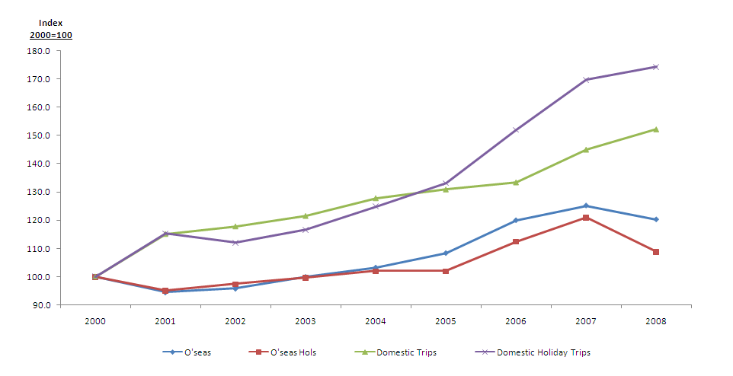
Figure 4: Overseas and Domestic Tourist Growth Rates, 2000-2008

Source: Fáilte Ireland

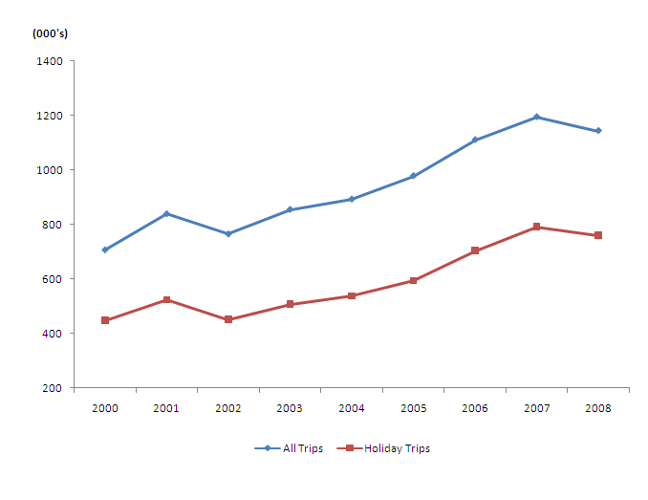
Figure 5: Real Increase in the Value of the Domestic Market, 2000-2008
Source: CSO, CHL

Trends in the domestic market include the following:

- The average length of trip has fallen by almost 17% since 2000: the drop in the average length of holiday trips has been greater, at nearly 22%, from 4.56 nights in 2000 to 3.57 nights in 2008. There was a steady downward trend during the period, reflecting the popularity of short breaks.

- The average spend per trip has increased in real terms since 2000: the increase up to 2006 was 18%, but this has fallen back, and the average in 2008 was just 6% above the 2000 figure. However, this contrasts with the substantial real drop in the average yield from overseas tourists.

- The shorter average trip duration combined with increased expenditure has produced a significant increase in yield: the average real increase in expenditure per day between 2000 and 2008 amounted to 28% for all domestic trips, and 24% in the case of holiday trips – see Table 2.3.

Table 2.3: Trends in Domestic Holiday Tourism, 2000-2008

Year | Total  Trips | Total Holiday Trips 000s | Spend on Holiday  Trips €m | Spend  2000 prices  €m | Nights  on  Holiday Trips  000s | Nights per Trip | Spend  Per  Trip | Spend  per Trip 2000 prices  €
2000 | 5,478 | 2,516 | 448 | 448 | 11,465 | 4.56 | 177.94 | 177.94
2001 | 6,307 | 2,902 | 550 | 524 | 13,227 | 4.56 | 189.42 | 180.57
2002 | 6,452 | 2,819 | 502 | 452 | 12,098 | 4.29 | 177.94 | 160.22
2003 | 6,657 | 2,933 | 576 | 507 | 13,009 | 4.44 | 196.35 | 172.88
2004 | 7,001 | 3,142 | 625 | 538 | 13,506 | 4.30 | 198.89 | 171.32
2005 | 7,173 | 3,348 | 707 | 594 | 13,676 | 4.08 | 211.11 | 177.39
2006 | 7,310 | 3,827 | 873 | 705 | 14,374 | 3.76 | 228.04 | 184.24
2007 | 7,942 | 4,271 | 1,028 | 792 | 16,359 | 3.83 | 240.72 | 185.45
2008 | 8,339 | 4,389 | 1,028 | 761 | 15,654 | 3.57 | 234.20 | 173.35

* Totals may not add due to rounding
Source: Derived from Fáilte Ireland Tourism Facts, successive issues

Although the number of domestic tourists has increased at a faster rate than overseas visitors during the past eight years, the share of total tourist bednights accounted for by the domestic market has fallen due to the reduced average length of stay - see Table 2.4. However, in the case of holiday bednights, the share taken by the domestic market has risen despite the shorter length of stay, due simply to the very high growth rate in the number of domestic holiday trips.

Table 2.4: Tourist Bednights, 2001 and 2008

Market | 2001  (000’s) | 2008  (000’s) | Change
Overseas Tourists | 44,552 | 59,337 | +33.2%
Domestic Tourists | 23,307 | 26,195 | +12.9%
Total | 67,759 | 85,532 | +26.2%
Domestic % of Total | 34.2% | +30.6%
Overseas Holidaymakers | 23,068 | 25,148 | +9.0%
Domestic Holidaymakers | 13,227 | 15,654 | +18.3%
Total | 36,295 | 40,802 | +12.4%
Domestic % of Total | 36.4% | 38.4%

Source: CSO, Fáilte Ireland

The impact of the rapid growth in the domestic market can be seen in the remarkable shift in the profile of market demand for hotel accommodation during the past eight years. In brief, the share of hotel guestnights attributable to overseas visitors fell from 46% in 2001 to 31% in 2008. At the same time the share attributable to the home market rose from 49% in 2001 to 66% in 2008.

The Northern Irish market has held a fairly constant share of 4% to 5%. This shift in demand means that 90% of the growth in hotel bednight demand between 2001 and 2007 was generated by the home market, and only 9% by overseas tourists. The industry has therefore become increasingly dependent on domestic demand and the evidence suggests that overseas visitors will, at best, only partially compensate for a decline in the domestic market, even when overseas markets are performing well.

Figure 6: Market Distribution of Hotel Bednight Demand
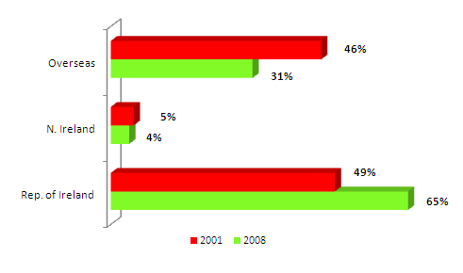

Source: Fáilte Ireland

Figure 7: Market Source of Growth in Hotel Bednight Demand, 2001-2007
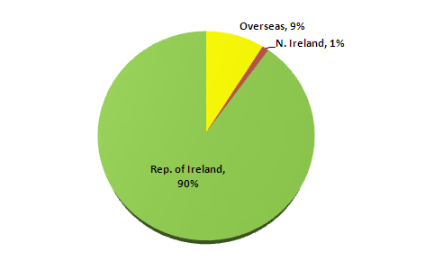

Source: Fáilte Ireland

2.2 Trends in 2009
2.2.1 Global Tourism
The downward trend in international tourism that developed during the second half of 2008 has accelerated in 2009. World tourist arrivals during the first quarter of 2009 were down by 10.6% on the same period in 2008. The drop was particularly severe in Europe which recorded a 13.4% reduction in arrivals. [The drop in Northern Europe, which includes Ireland, was 12.5%].

These results reflect the severity of the global economic crisis and its impact on tourism demand. However it may be noted that the decline has been from the record peak in tourism achieved in 2008, and demand has dropped back to 2007 levels which were themselves a record at the time. Moreover, the fact that the Easter holidays occurred in April in 2009 may have had an impact on comparative quarters, as Easter fell in March in 2008.

Having said that, the results for April show a continuing negative trend, at -2.3% globally and -3.3% in Northern Europe. The UN World Tourism Organisation reports that its Confidence Index is at its lowest level since 2003 and that current trends now suggest that the outturn for 2009 will be worse than previously thought. Factors affecting demand include:

- economic recession in major markets
- falling incomes and rising unemployment
- exchange rate fluctuations
- weak business and consumer confidence
- airline financial difficulties
- uncertainty about how swine flu will develop.

Taking these factors into account, the WTO expects international tourism to decline by between -4% and -6% in 2009. This will be the worst downturn in more than ten years, as indicated in Figure 8. Europe is expected to experience the largest drop in demand, ranging between -5% and -8% in 2009.

Figure 8: International Tourist Arrivals, World
(% change over same period of the previous year)

Source: World Tourism Organisation (UNWTO), June 2009

2.2.2 Tourism in Ireland in 2009
The indicators for Irish tourism in 2009 are almost universally poor. The number of visitors to Ireland for the first seven months of the year was down by 10.4% on the same period in 2008. In total, some 4 million trips were made to Ireland during the period to the end of July - the lowest number for this period since 2005 (Table 2.5). The drop in visits in May was particularly large, being 18.4% below the figure for May 2008. (However, the latter was exceptionally high at 14% above the result for May 2007.) The number of trips to Ireland in July 2009, at 759,600, was 9% below the figure for July 2008 and the lowest level of July arrivals since 2004.

As with the global performance, the downward trend in tourism to Ireland has been accelerating in 2009. All markets have been affected, with a particularly steep drop being recorded by the British market. Indeed, the fall in numbers of tourists from Britain accounted for 67% of the total decrease during the first seven months of the year. The decline in demand from Mainland Europe and North America has been much less severe.
Table 2.5: Tourism to Ireland, Jan-July 2009

Market | J-J 2007  (000’s) | J-J 2008  (000’s) | J-J 2009  (000’s) | Change in ‘09  (%)
Britain | 2,253.9 | 2,214.4 | 1,895.7 | -14.4
Mainland Europe | 1,471.3 | 1,520.7 | 1,423.6 | -6.4
North America | 620.7 | 605.1 | 577.3 | -4.6
Rest of World | 172.5 | 196.7 | 167.1 | -15.0
Total | 4,518.5 | 4,537.0 | 4,063.1 | -10.4

Source: CSO, Overseas Travel July 2009

At the time of writing, figures for domestic tourism in 2009 were only available for the first quarter. The findings of the CSO’s Household Travel Survey show that the number of trips in the first quarter was down by just 5% on the first quarter of 2008, but the number of nights was down by almost 9%. This was a relatively modest reduction when compared to the results for inbound travel by overseas tourists during the first quarter which showed a drop of 9% in visitors and over 12% in bednights. Moreover, the fact that the Easter holidays were in April in 2009 as opposed to March in 2008 would raise expectations of a greater year-on-year fall in the first quarter.

Table 2.6: Domestic Tourism, Jan-Mar 2009

Market | Q1 2008  (000’s) | Q1 2009  (000’s) | Change ‘09  (%)
Total Trips | 1,851 | 1,760 | -4.9
Total Nights | 4,626 | 4,221 | -8.8
Holiday Trips | 890 | 739 | -17.0
Holiday Nights | 2,336 | 1,706 | -27.0
Total Expenditure (€m) | 284.2 | 256.3 | -9.8
Holiday Expenditure (€000) | 181.0 | 137.8 | -23.9

Source: CSO Household Travel Survey, Q1 2009

The pattern of demand summarised in Table 2.6 shows that there was a much greater reduction in holiday trips and, especially, holiday nights which declined by -17% and -27% respectively in the first quarter compared to the first quarter of 2008. The shift of the Easter holidays to April undoubtedly had an impact, but the figures indicate a considerable cut back in spending on holidays.

Further evidence of the contraction in the domestic market can be found in the decrease in demand for outbound travel in 2009. The total number of overseas visits made by Irish residents fell by 9% in the first half, while the number of overseas holiday trips fell by 12%.

2.2.3 Outlook for 2009
The outlook for the remainder of 2009 is not encouraging. Although there are some signs emerging that the recession bottomed out in many countries during the second quarter of the year, the outlook remains uncertain and consumer demand is expected to remain weak. Meanwhile, the short-term outlook for the Irish economy is bleak. A summary of key indicators is provided in Table 2.7. These underline the weak nature of demand in our key markets.

A point to note from the data in Table 2.7 is that the comparative rates of inflation based on the Harmonized Index of Consumer Prices (HICP) do not show a major gain in competitiveness accruing to Ireland with respect to most of the key markets. The only exception to this is Britain where inflation was running at 1.8% in July, 2009. However, this rise is offset to a large extent by the weakness in sterling.

Table 2.7: Forecasts for Key Economic Indicators, 2009

 | Forecast for Year |  |  | Actual
Market | GDP  % | Unemployment  % | Consumer  Spending Sales | Inflation *  July ’09 % | Travel Spend  1st Quarter
Ireland | -7.9 | 12.6 | -7.0% | -2.6% | -9.8%
Britain | -4.1 | 8.2 | -3.5% | 1.8% | -15.6%
USA | -2.6 | 10.1 | -0.9% | -2.1% | -5.9%
Germany | -5.2 | 8.7 | 0.4% | -0.7% | -9.3%
France | -2.25 | 10.5 | 0.1% | -0.8% | -10.0%
Italy | -4.8 | 8.4 | -1.9% | 0.1% | -2.0%

* Harmonised Index of Consumer Prices except for USA.
Sources: ESRI, EC, IMF, OECD, Economist, HM Treasury, Bundesbank, ECB, INSEE, Dipartimento dei Tesoro (Italy), Bank of England, U.S. Federal Reserve, Conference Board.

The latest data on consumer confidence in the major source markets are a little more encouraging. The indices in Britain, Germany, France and Italy all have shown some uplift in the second quarter of 2009, although they remain some way below their position in 2008. In the U.S., consumer confidence has improved considerably since the start of 2009, but is low in historic terms. Confidence in the domestic market has also weakened in July, according to the KBC/ESRI Consumer Sentiment Index, but it is a little above the record low recorded in July 2008.

Taking the foregoing into account, the following economic trends are influencing the performance of Irish tourism in 2009:

- economic growth is very negative in all major source markets
- unemployment is continuing to rise in all markets
- inflation is minimal or negative in all markets
- consumer spending is contracting in Ireland, Britain and the USA
- travel demand and expenditure has dropped sharply in all markets, and is unlikely to improve during the remainder of the year
- consumer confidence is very weak in all major markets, but is beginning to stabilise
- the US dollar and pound sterling are, if anything, likely to weaken a little further
- oil prices are trending very slowly upwards
- air access capacity from Britain, the USA and Mainland Europe in summer 2009 is down by a little over 10% on summer 2008.

Taking these factors into account, a range of projected outturns for 2009 is summarised in Table 2.8.

Table 2.8: Projected Results for Irish Tourism, 2009

 | Overseas |  | Domestic
 | Visitors | Revenue | Trips | Revenue
Best Case | -8% | -12% | -8% | -13%
Central Projection | -10% | -18% | -11% | -16%
Worst Case | -12% | -21% | -14% | -20%

Source: CHL Estimates.

2.3 Outlook 2010-2015
The global market is in a very volatile condition, and this impacts heavily on consumer confidence and, hence, on tourism demand. This volatility makes it difficult to look ahead with any certainty.

However, it is clear that Ireland is facing into a difficult period as a tourist destination. Key points which highlight the scale of the challenge are as follows:
- Economic Growth: previous analysis has shown that changes in GDP and real income per capita in source markets affects the demand for travel to Ireland. The current economic outlook for most of our major source markets is that the recession will bottom out in the second half of 2009. A small upswing in 2010 is forecast for the USA, and this is expected to strengthen in 2011. Modest growth is now forecast for France and Germany in 2010, picking up further in 2011.The UK is also expected to achieve GDP growth of up to 1% in 2010, accelerating a little in 2011.

- Consumer Spending: it seems unlikely that consumer spending, including the demand for travel, will rebound quickly. High rates of unemployment will persist in 2010 and, in many countries, tax increases are likely to be levied to help improve public financial positions. Wage and salary increases are likely to be minimal, at best. Interest rates and oil prices may tend to rise. In these circumstances, disposable income may be reduced, and the savings rate may increase. Expenditure on tourism and travel will suffer in those circumstances.

- Competitiveness: in a weakened market, achieving and sustaining competitive advantage is critical. However, Ireland’s competitiveness as a tourist destination has weakened in recent years, and the country has lost market share. Aspects of Ireland’s competitive position are outlined in Section 3. It is evident that the challenge is considerable and that it will take time to restore the competitive position that the country previously enjoyed.

- Access Capacity and Costs: the cuts in capacity being implemented by airlines are likely to accelerate in the autumn and winter of 2009. In combination with rising fuel costs, it is likely that ticket prices will rise in 2010. Higher prices and reduced capacity will affect travel to Ireland. The imposition of high departure taxes or carbon taxes will exacerbate this position. For example, in Britain, the Air Passenger Duty will increase steeply over the next two years, although this will have a much greater impact on long-haul travel. [It may also encourage more people to consider travelling by sea ferry which would benefit Ireland].

- Domestic Market: the severity of the recession in Ireland means that tourism demand will be adversely affected in 2010 and 2011. It seems unlikely that there will be much improvement before 2012. Even if volumes begin to recover before then, low prices will keep revenue growth to a minimum.

Taking the above into account, a forecast for tourist volumes and revenues are set out in Table 2.9.

Table 2.9: Tourist Demand Outlook, 2010-2015

Year | 2008 | 2009 | 2010 | 2011 | 2012 | 2013 | 2014 | 2015
Overseas Visitors (000s) | 7,436 | 6,682 | 6,666 | 6,783 | 6,961 | 7,198 | 7,443 | 7,697
Overseas Revenue (€m) | 4,571 | 3,738 | 3,804 | 3,987 | 4,255 | 4,400 | 4,550 | 4,705
Domestic Trips (000s) | 8,339 | 7,505 | 7,130 | 7,201 | 7,417 | 7,788 | 8,255 | 8,751
Domestic Revenue (€m) | 1,546 | 1,294 | 1,180 | 1,260 | 1,335 | 1,441 | 1,569 | 1,706
Total Revenue (€m) | 6,117 | 5,032 | 4,984 | 5,247 | 5,590 | 5,841 | 6,118 | 6,412

Source: CHL Estimates. Notes: Revenues in 2008 prices; Northern Ireland visitors and revenues not included.

The projections for visitors and revenues are charted in Figures 9, 10 and 11, with a band of ± 5% each side of the main projection for 2010 on to indicate a potential range of values.

Key assumptions implicit in the projections in Table 2.9 are that:

- the leading European economies stabilize in 2010, and return to a modest growth path thereafter
- the U.S. economy returns to growth in 2010
- oil prices do not rise significantly above US€70 per barrel in real terms
- access capacity stabilises at 2009 levels and picks up from 2011 onwards
- the Euro does not strengthen further against the US$
- the Irish economy moves to restore its competitiveness and returns to growth by 2011
- overseas visitor expenditure per head falls sharply in 2009 by and gradually recovers to stabilise in real terms at the 2004-2008 levels
- domestic tourist expenditure per head falls by 7% in real terms in 2009 and by a further 4% in 2010, followed by a slow return to levels a little above 2008 by 2015.

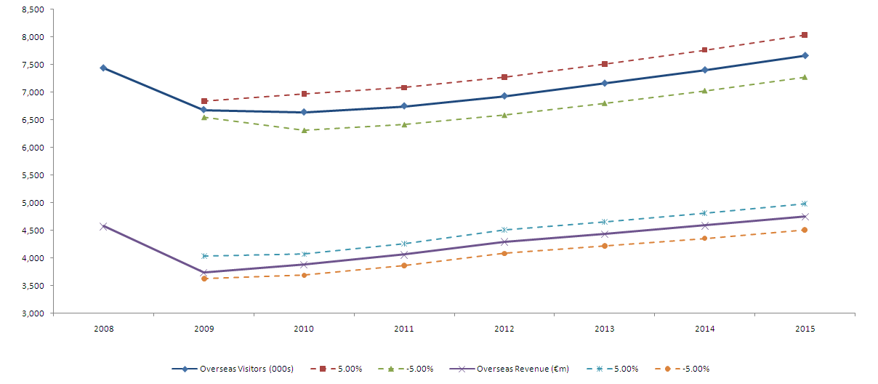
Figure 9: Overseas Visitors & Revenue Projections ± 5%, 2008-2015
Source: CHL Estimates

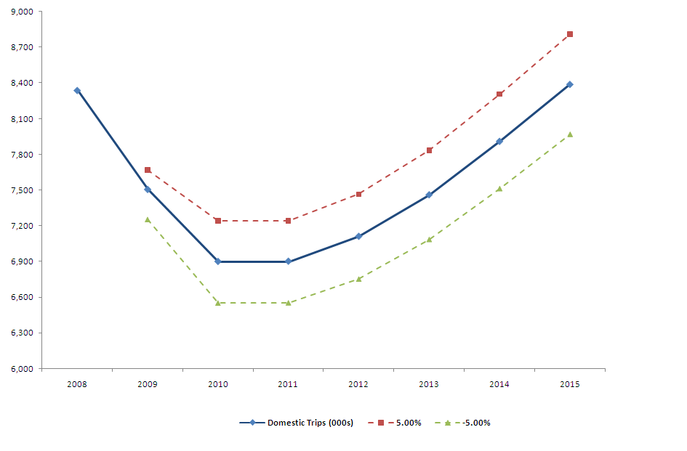
Figure 10: Domestic Trips Projections ± 5%, 2008-2015
Source: CHL Estimates
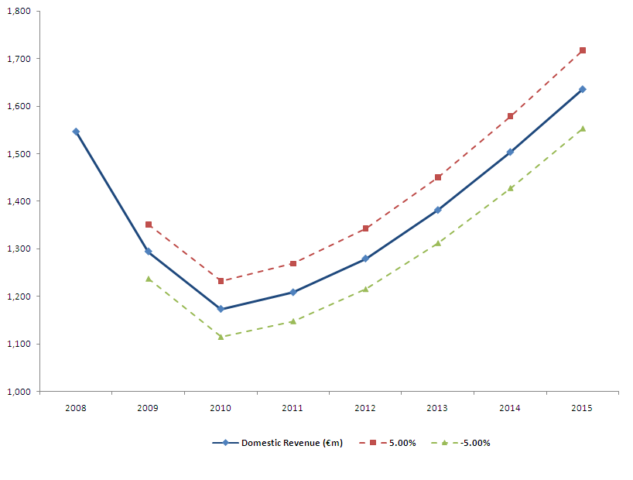
Figure 11: Domestic Revenue Projections ± 5%, 2008-2015
Source: CHL Estimates
3. COMPETITIVE POSITION

3.1 Introduction
In 2006, CHL completed a detailed analysis of Ireland’s competitiveness as a tourist destination on behalf of ITIC. This was updated in 2007. The analysis showed that competitiveness is a complex measure, especially when applied to entire economies and tourist destinations. It embraces a wide range of factors which extend into all areas of economic and social activity,

In the CHL report, the key factors influencing Ireland’s tourism competitiveness were gathered into a descriptive model to provide a framework for analysis. This model was adapted from the Competitiveness Pyramid, devised by the National Competitiveness Council, and the resulting Tourism Competitiveness Pyramid is shown in Figure 12.

Figure 12: Tourism Competitiveness Pyramid
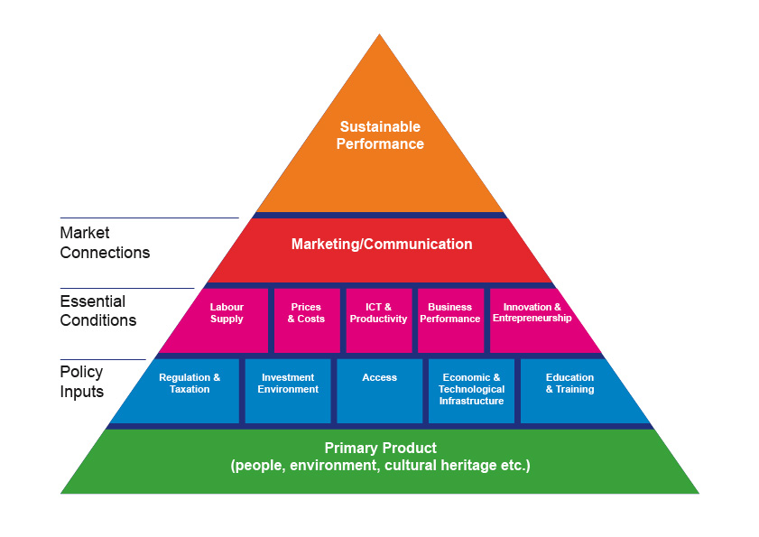
The Tourism Competitiveness Pyramid illustrates the diverse set of factors that influence Ireland’s position as a tourist destination. The findings of the analysis of these factors in 2007 showed that Ireland was facing growing challenges arising from a loss of competitive advantage in a number of areas. While, in more favourable economic circumstances, these challenges may have been weathered and weaknesses corrected over time, the global recession has thrown them into sharp relief. In particular, price competitiveness has become a major concern and cost control is a serious issue for the industry.

This section highlights current trends in Ireland’s competitiveness, and identifies priority issues that need to be addressed.

3.2 Ireland’s Competitive Performance
3.2.1 Overseas Markets
Market share is the litmus test of competitiveness. In broad terms, where Ireland has maintained or increased market share, this can be interpreted as maintaining or improving competitiveness. Conversely, declining market share implies a loss of competitiveness. Figure 13 shows Ireland’s share of World and European tourist arrivals from 1985 to 2008, the latest year for which comparative data are available.

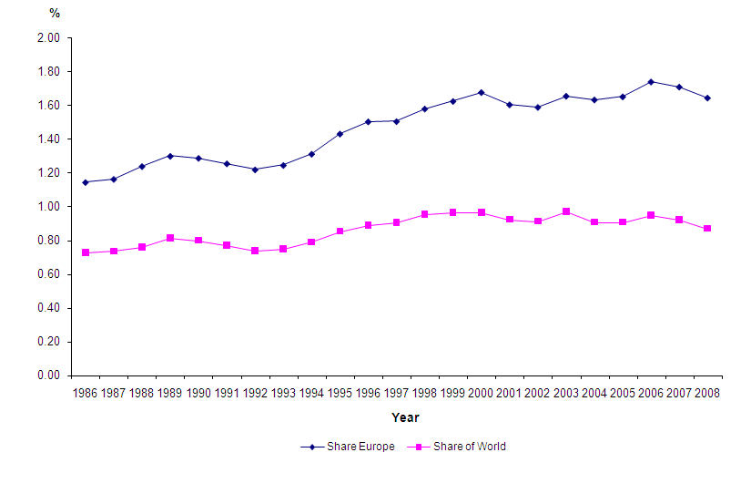
Figure 13: Ireland’s Share of World and European Tourist Arrivals 1985 - 2008
Source: WTO and Fáilte Ireland
Ireland’s share of world tourist arrivals grew from 0.78% in 1986 to reach a peak of 0.97% in 2003. It remained at a high level until 2006 since when it has slipped back to 0.87% in 2008, its lowest level since 1995. The trend in our share of European arrivals rose from 1.2% to 1.7% between 1986 and 2006, but has slipped back in 2007 and 2008 to 1.6%. This is evidence of a decline in competitiveness.

The same downward trend is found in Ireland’s share of Northern European tourist arrivals. This region comprises the UK, Ireland, Iceland and the Scandinavian countries (Denmark, Finland, Norway and Sweden). As shown in Figure 14, Ireland’s share of demand in Northern Europe peaked at 15.2% in 2003 but fell back to 14.1% by 2008, the lowest level since 1998.

Figure 14: Ireland’s Share of Northern European Tourist Arrivals 1985 - 2008

Source: WTO and Fáilte Ireland

Ireland’s share of outbound tourist demand from our four largest source markets is shown in Table 3.1. The figures show that while Ireland has strengthened its position in France and Germany, it has lost a significant share of the two largest markets – the UK and USA. This trend is consistent with the performance analysis in Section 2 which showed that Mainland Europe has been the primary source of growth in tourist arrivals in recent years.
Table 3.1: Ireland’s Share (%) of Outbound Tourist Numbers from
the Main Source Markets 2002-2008

Source market | 2002 | 2003 | 2004 | 2005 | 2006 | 2007 | 2008
UK | 8.4 | 8.8 | 8.0 | 7.8 | 8.0 | 7.6 | 7.0
USA | 3.4 | 3.4 | 3.3 | 3.1 | 3.2 | 3.2 | 2.8
Germany | 0.4 | 0.4 | 0.4 | 0.5 | 0.6 | 0.6 | 0.6
France | 1.3 | 1.4 | 1.2 | 1.1 | 1.2 | 1.3 | 1.4

Source: Tourism Ireland, 2009. Note: UK includes Northern Ireland.

3.2.2 Visitor Attitudes
Table 3.2 below lists the competitive advantages spontaneously identified by holidaymakers responding to Fáilte Ireland’s Visitor Attitudes Survey. The Irish people and the scenery continue to be Ireland’s leading competitive advantages, although the proportions of visitors who identify these features have declined. Culture and history have continued to be a significant advantage for 15% of survey respondents, but there has been a sharp decline in the proportions identifying other features as advantages. These include aspects that have traditionally been seen as distinctive elements of the Irish holiday experience – restful, relaxing, unspoilt environment, pubs and good accommodation.

Table 3.2: Ireland’s Competitive Advantages

 | % of Overseas Holidaymakers
 | 2000 | 2005 | 2007 | 2008
Irish people | 45 | 39 | 38 | 39
Scenery | 33 | 28 | 32 | 30
Culture/History | 15 | 15 | 17 | 15
English speaking | 15 | 14 | 11 | 12
Restful/Relaxing | 10 | 10 | 5 | 5
Unspoilt environment | 11 | 9 | 6 | 5
Access | 7 | 10 | 6 | 8
Drink/Pubs | 10 | 9 | 9 | 5
Quiet roads | 6 | 5 | 3 | 3
Good accommodation | 7 | 4 | 3 | 2
Prices/Value | 5 | 3 | 1 | 1
None | 2 | 4 | n.a. | n.a.

Source: Fáilte Ireland Visitor Attitudes Survey, 2008
While Ireland continues to rate highly for the friendliness of its people, the beauty of its scenery and the natural environment - the three most prominent decision drivers for choosing Ireland - the benefits of these primary attractors are being undermined by increasingly negative perceptions of value for money, as shown in Table 3.3. In 2000, over half (52%) of all overseas holiday visitors were ‘very satisfied’ with value for money in Ireland. By 2008, this proportion had dropped to 35%.

Table 3.3: Key Competitive Factors

 | % of Overseas Holiday Visitors
 | Decision Drivers |  |  |  | Very Satisfied
 | 2000 | 2005 | 2007 | 2008 | 2000 | 2005 | 2007 | 2008
Friendly people | 87 | 84 | 81 | 81 | 89 | 89 | 87 | 87
Beautiful scenery | 83 | 82 | 80 | 79 | 89 | 90 | 89 | 89
Natural environment | 77 | 77 | 71 | 70 | 79 | 81 | 80 | 79
Pace of life | 72 | 71 | 62 | 62 | 82 | 79 | 76 | 77
Cities, towns | 63 | 60 | 54 | 57 | 66 | 65 | 65 | 65
Way of life | 61 | 56 | n.a. | n.a. | 64 | 58 | n.a. | n.a.
Value for money | 64 | 59 | 55 | 58 | 52 | 42 | 40 | 35
Accommodation prices | 62 | 60 | 52 | 56 | 55 | 46 | n.a. | n.a.
Sea and air fares | 47 | 54 | 46 | 52 | 39 | 49 | 45 | 49

Source: Fáilte Ireland Visitor Attitudes Survey, 2008

Table 3.4 shows specific aspects of the Irish product that have been considered less than good value by overseas visitors since 2000. Key elements of the overall holiday experience - eating out, drink, general cost of living, and food in shops and supermarkets - lead the way in terms of visitor perceptions of poor value for money. Moreover, as the data in the table show, there has been a steep rise in dissatisfaction in recent years.

Table 3.4: Aspects Considered Less than Good Value

Overseas Visitors | 2000 | 2003 | 2004 | 2005 | 2006 | 2007 | 2008
Eating out | 11 | 26 | 28 | 29 | 27 | 42 | 55
Drink | 8 | 19 | 22 | 23 | 20 | 33 | 40
Cost of Living (general) | 8 | 17 | 19 | 20 | 21 | 36 | 42
Food in shops/supermarkets | 5 | 11 | 11 | 11 | 8 | 16 | 18

Source: Fáilte Ireland Visitor Attitudes Survey, 2008
3.3 Competitive Issues and Priorities
The Tourism Competitiveness Model, illustrated in Figure 12 above, identifies the range of factors that influence Ireland’s competitiveness as a tourist destination. The trends in performance, market share and visitor attitudes all indicate a weakening of Ireland’s competitive position in recent years. This loss of competitiveness, unless corrected, will both intensify the severity of the impact of the economic recession and act as a brake on recovery. The key issues and priorities for restoring competitiveness are highlighted in this section. The review covers:

- costs and prices
- labour costs
- taxation and regulation
- access
- product
- marketing
- human resources.

3.3.1 Cost and Prices
Price competitiveness represents only one of many dimensions of overall competitiveness. In general, as destinations develop and are successful, they become less price-competitive but they can maintain their appeal on the basis of successful management of other competitive advantages. The goal is to deliver a quality value-for-money experience that vindicates the price.

In Ireland’s case, however, the responses of tourists to Fáilte Ireland’s surveys indicates a growing dissatisfaction with value-for-money and a perception that Irish prices are simply too high. In times of recession, prices become a particularly important consideration for tourists who are dealing with reduced disposable incomes.

Figure 15 shows that, between January 2000 and April 2008, Ireland experienced a 35% loss in international price competitiveness, as measured by the real Harmonised Competitiveness Indicator. This loss of competitiveness reflects a combination of an appreciation of the Euro against the currencies of many of our trading partners (nominal HCI) and higher price inflation. There has been some improvement in 2009, but the position remains weak.

Figure 16 shows that Ireland’s rate of price inflation, as measured by the Harmonised Index of Consumer Prices, came into line with the Eurozone average in 2004 and 2005. Ireland rose above the average in 2006 and 2007, but has dropped below it in 2009. The trend in recent years has therefore been more favourable. However, it cannot be presumed that deflation in Ireland will automatically guarantee an immediate and sustained improvement in price competitiveness since many of our source markets are also experiencing deflation (see Table 2.7 on page 13).

Figure 15: Price Competitiveness Indicator for Ireland 2000-2009

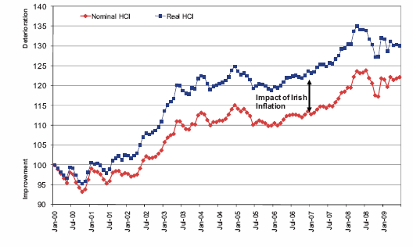

Note: the change in nominal HCI is driven by the appreciation of the Euro against the currencies of many of our trading partners. The gap between this and real HCI is driven by price inflation.
Source: NCC Annual Competitiveness Report 2009

Table 3.5 overleaf shows the change in the prices of selected goods and services between December 2006 to June 2009. These goods and services are components of the Consumer Price Index (CPI).
Figure 16: Harmonised Index of Consumer Prices

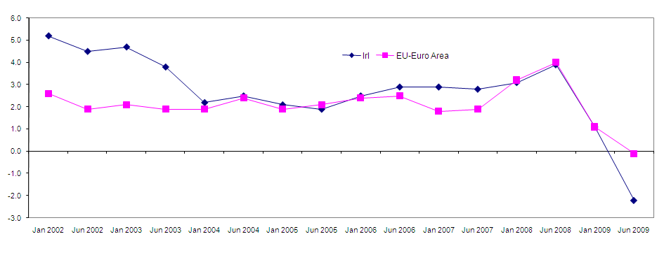
Annual % change
Table 3.5: Price Indices for Selected Tourism-Related Products, 2006- 2009
(December 2006 = 100)

Tourism Element | June 2008 | August 2009
CPI - Consumer Price Index | 107.9 | 101.7
Package Holidays | 102.0 | 107.4
Food & non-alcoholic beverages | 110.0 | 104.0
Alcoholic beverages | 105.9 | 107.0
Recreation & cultural services  - Cultural admittance  - Cinema | 107.9  109.3  104.9 | 109.9  110.7  106.2
Restaurants & Hotels  - Restaurants / cafes / bars  - Accommodation | 107.2  106.6  110.6 | 106.4  108.5  92.4
Bus fares | 108.4 | 125.4
Taxis | 100.0 | 108.2
Rail transport | 106.9 | 116.5
Air transport | 120.4 | 125.3
Sea transport | 105.4 | 100.5
Electricity, gas, other fuels | 113.6 | 106.0
Water supply, refuse, miscellaneous | 105.1 | 105.1

Source: CSO

The data in Table 3.5 show that the prices of many tourism-related goods and services have risen at a faster pace than the overall Consumer Price Index (CPI) during the past two years. A large part of the drop in the CPI between 2008 and 2009 was attributable to the reduction in mortgage interest rates. However, even if mortgage interest is excluded, the CPI in June 2009 was 103.5 which was still some way below the level of increase in most of the other items listed.

There has been a significant price reduction in hotel accommodation. Over-capacity and falling demand have been the primary drivers of the fall in hotel prices. On the other hand, bus and rail fares have risen very steeply, which is an unwelcome development in times of recession, and is also inconsistent with the goal of getting more people to use public transport. Air fares have also risen steeply which is not in the interests of an island destination.

Excessive price inflation carries significant risk for tourism. The general international holiday market in which Ireland competes is characterised by a high price elasticity of demand. This particularly affects the package holiday segments in which tour operators trade. Indeed, there is evidence that consumer demand is being driven by reduced prices and special offers which heavily erode profit margins. This price elasticity is tending to increase rather than decrease because:

- there has been, and continues to be, a steady growth in the number of substitute destinations which people can easily choose instead of Ireland

- holidays are not essential purchases for consumers and therefore the latter are more sensitive to increases in holiday costs

- as consumer incomes are under pressure, increases in the cost of holidays as a percentage of income directly increases price elasticity of demand

- prices have been relatively stable in recent years, which has also increased sensitivity to price changes.

The greater the level of price elasticity, the greater the drop in demand in response to price increases. There has been limited scientific research on estimating the price elasticity of demand for holidays in Ireland. However, a 1996 paper by Dr. Mary Walsh of the University of Limerick found that demand is price sensitive from all of the major European markets, and is particularly so in Britain.

3.3.2 Labour Costs
Tourism is a labour-intensive industry, and labour costs constitute a high proportion of overall operating costs. For example, hotel payroll costs were averaging just over 40% of turnover in 2008 compared to 34% in 2002. The ratio is even higher in the visitor attractions sector where payroll costs often exceed 50% of turnover. The steep increase in payroll costs combined with reduced activity levels has resulted in a sharp contraction in margins which threatens the viability of many enterprises.

According to the National Competitiveness Council, wage inflation in Ireland was approximately 50% higher than the Eurozone average during the 2004-2007 period. While there was a significant slowing in rate of increase of labour costs in 2008, data from the European Commission show that labour costs in Ireland have moved from being almost 10% below the Euro-15 average in 2000 to being 17% above the average in 2008 - see Table 3.6 overleaf.

While the recession has led to a fall in labour costs throughout the private sector, they remain high relative to our competitors. There is a dissonance between a labour-intensive industry, such as tourism, and a high labour cost economy, and the risk is that product and service quality will be negatively affected where appropriate staffing levels cannot be sustained in the face of rising costs. It is unlikely that Ireland can gain a competitive cost advantage relative to competing destinations while maintaining the second highest minimum wage in the EU. It is not so much the minimum wage itself that is the problem, but the upward pressure that its rapid increase has put on wage rates above it.
Table 3.6: Labour Costs in Industrialised Countries, 2000-2008
(data relates to average economy-wide labour costs, including social security contributions)

€ per annum | 2000 | 2008 | % change  ’00-‘08
Norway | 43,069 | 61,576 | 43.0
Luxembourg | 41,572 | 53,251 | 28.1
Netherlands | 36,835 | 49,036 | 33.1
Denmark | 35,469 | 47,924 | 35.1
Belgium | 37,645 | 47,612 | 26.5
Ireland | 30,343 | 46,577 | 53.5
France | 35,036 | 44,156 | 26.0
Germany | 37,909 | 43,571 | 14.9
Sweden | 36,497 | 42,733 | 17.1
Austria | 35,829 | 42,555 | 18.8
United States | 50,205 | 41,841 | -16.7
Finland | 30,950 | 40,933 | 32.3
EU-15 | 33,178 | 39,922 | 20.3
Euro-12 | 32,227 | 39,839 | 23.6
United Kingdom | 36,435 | 38,954 | 6.9
Canada | 33,403 | 38,234 | 14.5
Italy | 28,711 | 36,664 | 27.7
Australia | 27,574 | 34,386 | 24.7
Spain | 23,558 | 31,522 | 33.8
Japan | 49,695 | 30,460 | -38.7
New Zealand | 21,684 | 30,332 | 39.9
Greece | 17,675 | 27,839 | 57.5
Portugal | 15,252 | 19,875 | 30.3

Source: European Commission AMECO database

3.3.3 Taxation and Regulation
Ireland’s economic model has been based around fostering a positive environment for business with a regime of low direct taxes and relatively high indirect taxes. While direct taxes are now rising, as the Government urgently needs to generate revenue, indirect taxes in the form of VAT and excise duty have also been increased. Higher indirect taxes, especially VAT, have a significant impact on the price of Ireland’s tourism product.

There has been a very steep increase in public sector charges and in the cost burden imposed by new regulations and new regulatory bodies. As a result, the public sector has been having a direct negative impact on cost competitiveness.

VAT
Table 3.7 shows that Ireland is in a relatively weak position in terms of tourism VAT. In absolute terms, Ireland’s standard VAT rate is the 5th highest in the EU and this pushes up all consumer prices. Ireland is ranked 7th highest in terms of VAT on hotel accommodation.

Table 3.7: Irish VAT Rates relative to the rest of the EU (EU 27)

 | Ireland | Ranking (of 27) | 2 Lowest
Standard Rate | 21.5% | 5th highest | 15%, 15%
Hotel Accommodation | 13.5% | 7th highest | 3%, 5%

Source: European Commission, 2009

The already weak competitive position on hotel VAT rates is worsened by the fact that other countries allow VAT on hotel expenditure as a business input. This is not permitted in Ireland. In fact, Ireland has the highest VAT rate among those EU countries that do not allow VAT on hotel accommodation as a business input.

The high VAT rates in Ireland and the non-recoverability of VAT as a business expense, other than for conferences, have a serious impact on the price competitiveness of business and leisure tourism. It seems inappropriate, that at a time of sharply rising price sensitivity on the part of consumers, that the standard VAT rate was increased to 21.5% in December, 2008.

Departure Tax
The €10 airport departure tax introduced this year on passengers travelling to international destinations is an unnecessary disincentive to tourism. Our competitors are moving in the opposite direction, and are avoiding the creation of barriers to travel. It is notable that Belgium, Denmark, the Netherlands, Spain, Sweden and Malta have all either abolished departure taxes or cancelled plans to introduce them. Most other EU Member States do not impose such a tax. Indeed, within the EU, only Ireland, the UK and Greece maintain a departure tax, and Greece has suspended its tax for the airports located in its prime tourist destinations.

There has been a sharp decline in tourist traffic through Irish airports, and the departure tax will not realise anything close to the revenue targets suggested by the Government in advance of its introduction. As an island destination, Ireland is particularly dependent on air access. The reduction in access costs, driven by low cost airlines and ferry companies, has been a major contributor to Ireland’s success in tourism during the past 20 years. It is a costly mistake to reverse these gains through the imposition of a departure tax as this will impact on visitor arrivals. This tax should be scrapped immediately.

Local Authority Charges
Local authority charges have risen continuously and steeply over the past decade. Apart from substantial increases in rates, there have also been steep increases in other areas such as water and waste charges. For example, the Consumer Price Index shows that water supply, refuse and waste charges rose by 130% between December 2001 and August 2009 - overall inflation during the same period was just 20%. In other words, these charges rose by more than six and a half times the rate of inflation. This trend is continuing, despite general deflation: the National Competitiveness Council has projected that the inflation in public services and administered prices will average 13.2% in 2009.

The business community already contributes a very large share of local authority revenues. In rural area with low levels of industry, it is often the tourist businesses - hotels, restaurants etc. - that carry the main burden of local authority rates and other charges. Given the circumstances in which the industry finds itself, there is no capacity to bear further increases in local authority rates and charges. Indeed, such charges should be reduced or, at least, frozen for a sustained period. Moreover, there should be greater transparency in the structuring of charges on businesses to ensure that there is clarity and equity in their estimation and levying.

Regulation
The level of regulation imposed on tourism businesses, especially those in the accommodation and catering sectors, is creating unduly high costs in fees and compliance procedures. These regulations apply to almost all aspects of business, and include labour, health and safety, and environmental matters. Overall, there needs to be a more supportive regulatory environment, especially for small and micro-enterprises, and the compliance costs and charges levied by regulatory bodies and local authorities must recognise the prevailing economic circumstances.

A brake should be applied to the steady flow of new regulations and associated fees, and existing regulations and charges need to be re-examined to determine their usefulness, cost and efficiency. In general, bodies charged with regulatory functions should focus on the development of an advisory rather than adversarial approach, and assist them to achieve compliance.

3.3.4 Access
Ireland’s inbound tourism depends on maintaining a high level of air and sea access routes and capacities into the island, and avoiding and eliminating unnecessary barriers. The issue of the airport passenger departure tax has already been mentioned. Other obstacles include lengthy and costly visa procedures for citizens of new and developing markets, such as India and China, and slow immigration processing at Dublin Airport which can lead to long delays for arriving passengers.

Given Ireland’s island location, international surface and air connectivity is the lifeblood of the economy, and of tourism in particular. A real danger exists that falling yields and load factors, coupled with further airline consolidation, may lead to the loss of air services to the island.

The position regarding air access capacity from Ireland’s principal source markets is summarised in Table 3.8. Following a period of sustained growth, there have been substantial cuts in capacity in 2009, especially from Britain and the USA (down 11.3% and 10.6% respectively).

Table 3.8: Weekly Air Access Capacity to the Island of Ireland, 2005-2008

Market | Summer  2005 | Summer  2006 | Summer  2007 | Summer  2008 | Summer  2009 | % +/-  ‘08-‘09
Great Britain | 242,008 | 254,626 | 250,325 | 268.644 | 238,366 | -11.3%
USA | 27,030 | 29,431 | 35,324 | 33,178 | 29,673 | -10.6%
France | 20,863 | 25,571 | 28,916 | 33,277 | 32,217 | -3.2%
Germany | 18,981 | 21,624 | 20,123 | 21,943 | 20,682 | -5.7%
Spain | 17,706 | 25,088 | 39,422 | 41,417 | 40,695 | -1.7%
Italy | 10,244 | 14,486 | 16,871 | 16,156 | 16,616 | +2.8%
Netherlands | 10,891 | 10,636 | 10,636 | 11,988 | 10,069 | -16.0%
Belgium | 6,281 | 6,420 | 5,097 | 5,271 | 5,286 | +0.2%
All Europe Total | 109,896 | 147,074 | 176,518 | 190,726 | 171,327 | -10.2%

Note: Capacity is measured as the number of direct, scheduled seats available one-way per week.
Source: Tourism Ireland, 2009
The airline industry worldwide is in a precarious position. Slowing economic growth and escalating oil prices drove the industry to estimated record losses of $16.8 billion in 2008. While the cost of fuel has fallen, this has been brought about by the severity of the global recession which is impacting on passenger travel and freight. Given the continued deterioration of the global economy in the first half of 2009, IATA has revised its airline financial forecast for the year downward to a projected cumulative loss of $11 billion on a revenue drop of $80 billion. This 15% reduction in revenue is unprecedented (the drop after 9/11 was 7%) and it is likely that recovery will take several years. Among the consequences for Ireland will be further cuts in routes and capacities, and these will act as a restraint on recovery in demand.

The position regarding sea access is more encouraging. As shown in Table 3.9, the capacity on routes to Britain has been maintained at 2008 levels, while that on routes to France has actually increased by 11%.

Table 3.9: Weekly Sea Access Capacity, 2006 – 2009

Market | Summer 2006 |  | Summer 2007 |  | Summer 2008 |  | Summer 2009
 | Car Spaces | People | Car Spaces | People | Car Spaces | People |  | Car Spaces | People
Great Britain | 58,380 | 231,000 | 57,200 | 231,000 | 57,005 | 225,750 |  | 56,682 | 225,750
France | 2,250 | 7,782 | 2,250 | 7,782 | 2,425 | 7,502 |  | 2,585 | 8,302
Total | 60,630 | 238,782 | 59,450 | 238,782 | 59,430 | 233,252 |  | 59,267 | 234,052

Source: Tourism Ireland, 2009

Ireland enjoys excellent cruise and high-speed ferry access from the UK and France, and it is critically important that present service levels be maintained. As their services are also very reliant on freight business, the decline of imports and exports presents additional challenges. Demographics point to an ageing population in the UK and Europe, people with more time on their hands. This is an ideal target market for Ireland, and presents good prospects for ferry business growth in the future.

The challenge for Ireland during this economic downturn is to maintain, in so far as is absolutely possible, the present air and sea access levels. From the regional distribution perspective it is important that the present service levels are maintained to regional airports. That being said, it is improbable that this goal can be achieved beyond Shannon and Cork, given the new economic environment which will prevail for some time. The issue of whether the island needs or can economically justify 11 airports is likely to come into sharp focus in the coming years.
Product improvements such as the new Terminal 2 at Dublin Airport will mean that tourists entering the country from next year will have a more positive first experience than in recent years, where the existing terminal has been congested and in need of refurbishment. It will be important we continue to invest in critical infrastructure so as to ensure that the quality and efficiency of our tourism product offering for our tourists is maintained and developed.

3.3.5 Product
Tourism is an ever-changing business and to stay ahead requires constant investment in the product. Product development is briefly assessed here under three headings:

- the primary product
- the tourism accommodation stock
- tourist activities and attractions.

Primary Product
Market research over the years has consistently shown that the main attractors for visitors to Ireland - and our principal competitive advantages with regard to product - are Irish people, scenery, the natural environment and our cultural heritage. These attractors constitute the primary tourism product. The national responsibility is to protect and preserve these assets, to enhance them if possible, to educate residents and visitors about them, and to enable access. They are the foundations of the tourism industry and Ireland’s ability to compete is threatened by any damage to, or diminution of, these assets.

There has been much investment in cultural heritage during the past decade. However, less attention appears to have been given to scenery and the natural environment, and responses by visitors to Fáilte Ireland’s Visitor Attitudes Survey suggest that our natural environment is now much less of a competitive advantage than it has been in the past.

A failure to address threats to our primary product will result in their steady deterioration with serious consequences for tourism. In particular, our environment – both rural and urban - which is at the heart of the Irish tourism product, requires careful stewardship and nurturing. All parties have a role in its protection and presentation to visitors with sustainability being a governing principle in planning, development and operations. The tourism industry needs to step up its investment in green operating practices, and this should be promoted actively to enhance the image of Irish tourism. Eco-tourism should become a strength of the Irish tourism product range.

Accommodation
During the past decade, there has been considerable investment in the tourist accommodation stock, especially in hotels. Encouraged by tax-based incentives, the number of hotels has doubled in the past 13 years, and the bedroom stock has grown from 39,763 in 2001 to 60,148 in 2009, an increase of 51%. This excessive growth in capacity was offset initially by a greater propensity among tourists to stay in hotels, especially on the part of domestic holidaymakers. However, the downturn in demand in 2008 (which was accompanied by a further increase in capacity) led to a sharp fall in occupancy rates to 58% nationally, the lowest level since 1994 – see Figure 17.

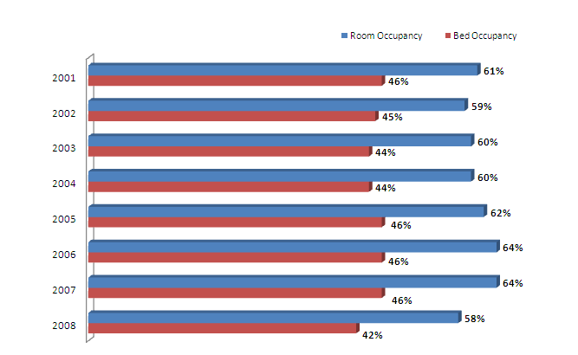
Figure 17: Trend in Hotel Room & Bed Occupancy Rates
Source: Fáilte Ireland.

As occupancy rates and prices have continued to fall in 2009, profits have dropped sharply. The outlook for 2010, as indicated in Section 2, is for a further contraction in demand. The Irish Hotels Federation (IHF) has described the hotel sector as being in crisis, and a growing number of properties have gone into receivership. The IHF estimates that there is excess capacity amounting to 12,000 rooms, and that this needs to be taken out of the market. If this reduction is not achieved through an orderly restructuring of the sector, it will happen in a chaotic fashion which will cause lasting damage. Possible measures include full or partial closure of hotels, especially those in unviable locations, conversion of properties to other uses, and changes in the regulations governing hotel capital allowances to allow investors to exit early and their hotels to close.

Activities and Attractions
In seeking to strengthen our tourism product, the emphasis in the coming years must be on the key attractors. Visitor attractions, including experience-based attractions such as the Guinness Storehouse, and heritage sites such as Blarney Castle, are very important elements of the Irish tourism product. Attendances at both admission-charging and free attractions indicate a strong enthusiasm among visitors for cultural, historical and heritage, and craft-based tourism products. There is clear scope for strengthening product development, innovation and integration in these areas.

Ireland’s singularity as a heritage destination lies in its long and well-recorded history. The OPW has within its portfolio an array of heritage sites of considerable scale and of great historical importance. Much credit is due to the OPW for its work in protecting and conserving these sites. However, good physical access to, and interpretation of, key sites are basic requirements for visitors. It is also essential that the operating policies adopted at such sites are tourist friendly and take into account the profile of demand - for example, site tours should either accommodate all of the tourists on a coach in one go, or divide them into smaller groups to be taken around simultaneously. Opening times and tour times should respond to market needs.

Sustained public sector investment in facilities associated with the tourism product is necessary and fully justified in terms of the economic benefit which would accrue, and the recovery potential which exists for Irish tourism. The tourism capital grant fund reduced this year should be fully restored to Fáilte Ireland. This allocation, though small in the context of overall public expenditure, leverages substantial investment in critically important tourism facilities throughout the country. Government must continue to direct investment towards the tourism product so that maximum advantage can be taken from the recovery in international travel which will commence in 2010 and accelerate in 2011 and 2012.

3.3.6 Marketing
Marketing is a vital driver of tourism growth, since it seeks to shift available international tourism demand towards Ireland. The task of marketing Ireland abroad is becoming progressively more difficult due to:

- the entry of many new destinations to the market
- changes in consumer behaviour, notably, the trend towards late booking
- the transformation in sales and distribution channels from fixed locations to the Internet; and
- the continuing need to counteract the characterisation of Ireland as an expensive holiday destination.

It is imperative that in the present down-cycle the commitment to overseas (and domestic) marketing is maintained and, if possible, increased. Any diminution of the commitment will assuredly lead to loss of market share and any such loss will be extremely difficult and expensive to recover. Moreover, a cut-back now would undermine the considerable investment that has been made in building the brand.

More than 80% of Ireland’s overseas visitors originate in Europe and it is probable that, for the foreseeable future, Ireland’s principal markets will remain the UK, the US and Continental Europe. However, the tourism marketing agencies should, as a matter of urgency, review their investment allocation by market. Given that resources will always be finite, there is a real risk of spreading these too thinly over several markets when a greater return might be achieved by concentration on best prospects. A case in point is the disappointing performance of the German market relative to its potential and the strength of its economy. It is also clear that the performance of Ireland’s biggest market, the UK, has been disappointing over the last decade. This is an issue requiring urgent attention.

It is essential that the application of national marketing resources be redirected to markets and to media that present best prospects for rapid recovery. Brand building has been successful for Tourism Brand Ireland and further investment should not be neglected. However, there should be a substantial tactical shift of resources towards product offerings, and web-based marketing should replace T.V. campaigns where budget levels do not allow for adequate impact.

Even allowing for the severe and prolonged downturn which the domestic market is undergoing, Ireland is and will remain the most important business source for much of the tourism product, and for several regions and resorts. Fáilte Ireland must therefore continue with strong domestic marketing initiatives.

3.3.7 Human Resources
People are an integral part of the tourism product. Within the industry, service quality is a function of management competence and employee expertise. Both are shaped by skills development and training.

However, skills development in the sector is inhibited by a number of factors:

- Most tourism-related businesses are small or medium sized. This makes it difficult both to provide the time and the funding for training.

- Labour turnover in the industry is high, at an estimated 25% annually. This weakens the incentive to invest in staff training, since the returns are uncertain.

- Exit rates from the industry are also high, with some 50% of those leaving a tourism-related job quitting the industry entirely. As a result, much training investment is lost not just to the individual business, but also to the industry.

- Non-Irish nationals now comprise in the region of 30% of all those working in hotels and restaurants. These workers are highly mobile and hence the incentive to invest in upgrading their skills is weak.

These are formidable barriers to surmount. However, if they are not dismantled, the future service quality of Irish tourism-related products will be compromised. It is vital that the industry strengthens its commitment to human resource development and that the Government remains committed to the €149m allocation to Fáilte Ireland for investment in training and human resources over the period 2007-2013.

The recession is likely to see the re-entry of many more Irish people into the industry. This is to be welcomed. Particular attention should be paid to the promotion of career paths within the industry and the retention of people working in tourism through continuous professional skills development.

4. EMPLOYMENT IN TOURISM

4.1 Total Employment
Tourism employment estimates prepared by Fáilte Ireland are provided in Table 4.1. These show that the numbers employed in the industry fell from the peak of almost 304,000 reached in 2007 to an estimated 258,000 in 2008 – a drop of 15%. Most (over 95%) of this drop was accounted for by an apparent sharp contraction in employment in the public house and licensed restaurant sectors. However, changes in survey methods in 2007 may have produced an over-estimate of the numbers employed in pubs and restaurants, and the actual drop in employment in 2008 may not have been as large as suggested by the data in Table 4.1.

Table 4.1: Employment in Tourism, 2007-2008

Sector | 2007 | 2008
Hotels | 65,473 | 64,854
Guesthouses | 3,565 | 3,956
Self-catering | 4,553 | 4,468
Licensed Restaurants | 63,575* | 46,716
Non-licensed restaurants | 13,472 | 14,535
Public Houses | 93,028* | 64,918
Tourism Services and Attractions | 60,024 | 58,127
Total | 303,690 | 257,574

* These figures may be over-estimates arising from a change in survey methods in 2007. The corresponding figures for 2008 are considered to be more accurate.
Source: Fáilte Ireland, 2009

Employment in the catering and tourism services and attractions sectors can be considered to be fully dependent on tourism. However, employment in restaurants and public houses is only partially dependent on tourism since establishments in these sectors usually generate much or most of their business in their local area.

In the course of a survey of employment in tourism conducted by CHL in 2003, respondents were asked to estimate the share of their turnover attributable to out-of-State tourists (i.e. tourists from overseas and Northern Ireland). Their responses were as follows:
- licensed premises: 21% of turnover attributable to tourists
- non-licensed restaurants: 20% of turnover attributable to tourists
- licensed restaurants: 28% of turnover attributable to tourists.

Based on their relative share of total tourist nights, inclusion of domestic tourists would add one-third to these proportions. Taking this into account, and assuming employment is directly related to turnover, the following adjusted estimate for tourism-dependent employment in 2008 may be made:

Table 4.2: Adjusted Estimate for Tourism Dependent Employment, 2008

Sector
Hotels | 64,854
Guesthouses | 3,956
Self-catering | 4,468
Licensed Restaurants | 17,285 | (37% of total)
Non-licensed restaurants | 3,924 | (27% of total)
Public Houses | 18,177 | (28% of total)
Tourism Services and Attractions | 58,127
Total | 170,791

4.2 Status of Employment in Tourism
Fáilte Ireland have produced an analysis of the distribution of employment in tourism by status. The results are summarised in Figure 18 overleaf. In brief, 44% of total employment is full-time, year round, and a further 32% is part-time year-round. In total, therefore, 76% of the jobs in tourism provide year-round employment. A further 19% of jobs are seasonal - almost equally split between full-time and part-time - and the balance of 5% are unpaid jobs filled by family members, volunteers and trainees.

The data in Figure 18 apply to the total employment in the sector of 257,574 in 2008 – see Table 4.1. In assessing the status of the adjusted total of 170,791 jobs dependent on tourism, specific allowances need to be made for the likely seasonality of tourism-related employment in pubs and restaurants. In 2003, 16% of the jobs in pubs and licensed restaurants and 6% of those in non-licensed restaurants were seasonal. Assuming that all of these seasonal jobs are tourism dependent, the status of employment in the adjusted total in 2008 may be estimated as follows:

Figure 18: Status of Employment in Tourism, 2008
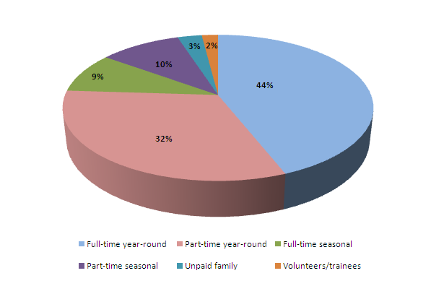

Table 4.3: Status of Tourism Dependent Employment

Sector |  | %
Year-round | 122,604 | 72%
Seasonal | 48,187 | 28%
Total | 170,791 | 100%

4.3 Future Trends
As the analysis of future trends in tourist demand in Section 2 showed, there is a great deal of uncertainty about how tourism will perform over the coming three years. While it is expected that the global economy will begin to recover in 2010, there will be a considerable degree of variation between different countries. In particular, it is anticipated that recovery will be slower in Ireland due to the greater severity of the recession here.

If it can be anticipated that employment in tourism will follow the performance of the industry in terms of activity and revenue, the numbers employed in the industry (based on the adjusted total) may be projected as set out in Table 4.4 overleaf.

The figures in Table 4.4 indicate a very substantial drop in 2009, following a similar fall in 2008. There is likely to be a further, but much smaller contraction in 2010, followed by a modest upturn in 2011 and 2012.

Table 4.4: Projected Trend in Tourism Dependent Employment

Year | Total
2008 | 170,791
2009 | 142,590
2010 | 141,000
2011 | 146,000
2012 | 154,000

There is a risk that the actual outturn could be worse than indicated in 2010 should the performance of the domestic economy and domestic demand deteriorate further than currently projected, and if the hotel sector, in particular, experiences widespread business failure and closures.

The standard deviation from the average for overseas tourist nights was 0.21, and that for overseas holiday tourist nights was 0.18.
Mary Walsh: ‘Demand Analysis in Irish Tourism’, Journal of the Statistical and Social Enquiry Society of Ireland, Vol. XXVII, Part IV, 1996.
CHL Consulting: ‘Ireland’s Competitive Position in Tourism’, ITIC, 2006, updated November 2007.
WTO figures are for all arrivals, not just ‘promotables’. Ireland’s figures are for all out-of-state tourists, including Northern Ireland.
Includes Northern Ireland
Mary Walsh, ‘Demand Analysis in Irish Tourism’, Journal of the Statistical and Social Inquiry Society of Ireland, VOL XXVII, Part IV’, 1996. Overall, the elasticities were found to range from less than 1 to 2.6 - i.e. that the proportional changes in demand in response to changes in Irish holiday prices range from under 100% to 260% of the amount of change in price. Based on this analysis, it is reasonable to assume that the price elasticity of demand for Irish holidays is at least unitary and negative - i.e. demand changes in inverse proportion to price. Thus a 1% increase in price will induce a 1% drop in demand.
Horwath Bastow Charleton: ‘Ireland & Northern Ireland Hotel Industry Survey 2009’.
CHL Consulting Co. Ltd. ’Tourism Business and Employment Survey 2003: Volume 8: Summary’, prepared for Fáilte Ireland, 2003

